**Milestone 4:**

1. Draw the architectural context diagram to represent the architectural context of your

software, which is part of architectural design.

2. Draw component diagrams to represent the components of your software and their

relationships, which is the core of architectural design. (These components along with

their relationship are the architecture of your software.)

**Team: CABS**

Marcus Blaisdell

Vivek Sandhinti

Christian Asivido

Joseph Crissey

1.

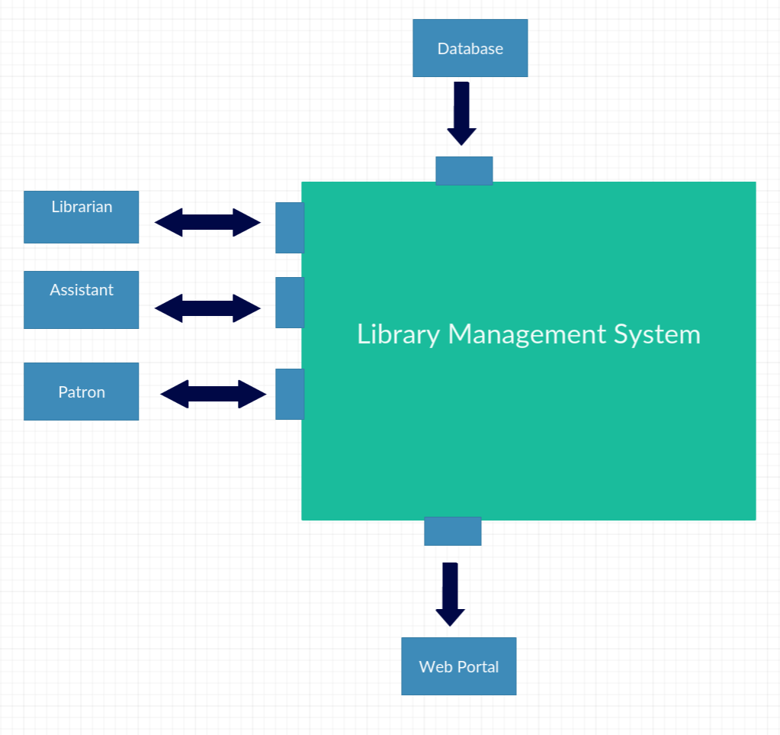

2.

